# removing the NA value from the dataset
hapiness_report_2022 <- hapiness_report_2022[!is.na(hapiness_report_2022$income), ]

# merging the 4data types of income column into one
hapiness_report_2022$group_income <- ifelse(
hapiness_report_2022$income %in% c("High income", "Upper middle income"),
"Max income",
"Min income"
)

# is this normal data?
hist(hapiness_report_2022$`Hapiness Score`)
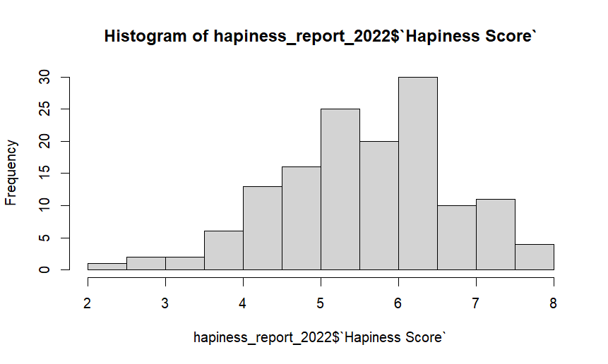

#clearly labelling the histogram:
hist(hapiness_report_2022$`Hapiness Score`,
+ main = "Distribution of Happiness Scores (2022)",
+ xlab = "Happiness Score (0–10 scale)",
+ ylab = "Frequency",
+ col = "lightgray",
+ border = "white")

